

Capture the joy of the holiday season
with a beautiful, Mini Holiday Photo Album:

What could be more perfect for Grandma or other family members than a festive holiday photo album created just for them? Use your favorite creative software or Microsoft® Word to add photos and personalize these holiday photo pages then print using a PictureMate® or any Epson Stylus printer. Gather your favorite holiday photos and you’ll have all the ingredients for a holiday gift that will be remembered all year long.

Materials Suggested:
- 4”x6” Epson Premium Glossy Photo Paper
- An Epson Stylus Photo Printer.

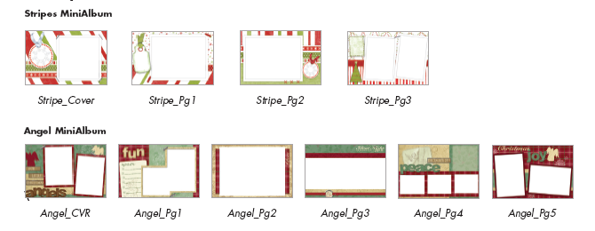

Instructions for using image editing software:

Step 1: Choose your favorite 4"x6" mini album design. Click on the selected files to open as .pngs and import into your preferred image editing software.

Step 2: Personalize the fronts of your mini album pages with a holiday greeting, personal message, name and/or date. Use the project photos as a guide.

Step 3: Add your digital photos onto new layers in each of your page documents. Make sure the photo layer is under the page design and type layers, if it's not, simply drag the photo in your layer pallet to the bottom of the layer box.

Step 4: Resize or crop your photos as needed to show through the opening on the mini album page
designs.

Step 5: Your personalizing is complete and ready to print. Remember to choose the correct paper size and
paper type setting in your printer driver. Print your mini album cover and each page.

Step 6: If you’d like, print the background pages and paste them to the back of your album pages.

Step 7: Embellish pages and assemble mini album as desired.

Instructions for using Microsoft® Word:

Step 1: Click on the selected mini album cover and pages you wish to create, each will open as a separate Microsoft® Word document.

Step 2: Add your personalized greeting, name and/or date on each page by highlighting the areas marked "Place Type Here". Note that once the text is highlighted, you can type your personalized message in the font style, size and color of your choice. Use the project photo as a guide.

If you're using an Epson PictureMate® Personal Photo Lab to place your photos, skip steps 3 and 4.

Step 3: To place a digital photo: go to the “Insert” pull down menu, scroll down to “Picture” and slide your curser across to “From File”. Browse your hard drive or CD for a photo and click on it to select it. Under “Format” select “Format Picture”. Choose the “Layout” tab, then select “in front of text”. This will put your photo on top of any text or graphic in your layout. Crop and resize your photo as needed. Use the project photos as a guide.

Step 4: Your personalizing is complete and pages are ready to print. Remember to choose the correct paper size and paper type setting in your printer driver.

Step 5: To add photos to your printed 4"x6" mini album using your Epson PictureMate® printer, print your photos according to the sizes indicated on each of the mini album page templates.

Step 6: Trim your printed PictureMate® photos with a craft knife. Using adhesive, apply them to the printed 4"x6" pages.

Step 7: If you’d like, print the background pages and paste them to the back of your album pages.

Step 8: Embellish pages and assemble mini album as desired.

